1788 - 1791 Tax Lists – Pruitt, etc. by Virginia County
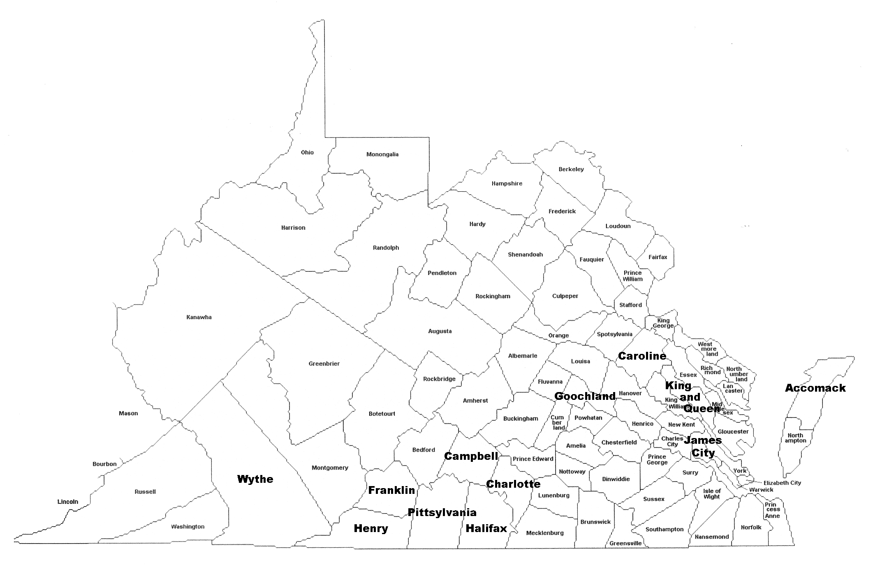

Accomack County
Prewet, George
Prewitt, William

Campbell County
Prewitt, Bird
Prewitt, Robart

Caroline County
Pruett, William

Charlotte County
Prewett, Joseph

Franklin County
Prewit, David
Prewit, Eligah
Prewit, John

Goochland County
Prewit, Abraham
Prewit, Allan
Prewit, Haward
Prewit, Obadiah

Halifax County
Prewit, Allexander
Prewit, Michael
Pruett, William

Henry County
Prewitt, Micajah

James City County
Prewit, Benjamin
Prewit, Benjamin
Prewit, Benjamin
Prewit, James
Prewit, Mary

King and Queen County
Prewitt, Francis
Prewitt, Francis
Prewitt, James
Prewitt, Reubin

Pittsylvania County
Prewet, Archibald
Prewit, Richard
Pruett, John, Jr (Group F)
Pruett, John, Sr (Group F)
Pruett, Joseph (Group F)
Pruett, Joseph (Banister)
Pruett, Joshua
Pruett, Samuel (Group F)
Pruett, Samuel, Jr (Group F)
Pruett, William (Group F)
Pruett, Zachriah (Group F)

Wythe County
Pruett, John

