Maston Pruett deceased, property sale

Southern Recorder, Oct. 23, 1849
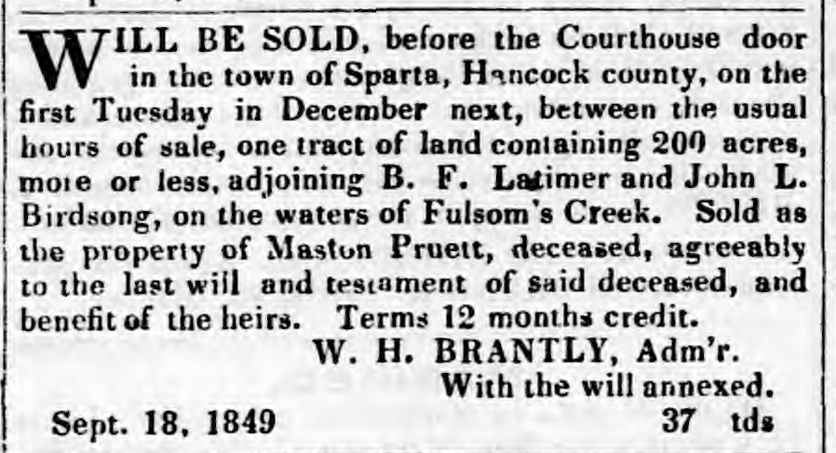

Submitted by Elaine Pruett 9/13/12

